**The Strategic Imperative of Inventory Control**

**Management for Unlocking Success of an**

**Organization**

## Submitted by

L.Kalyani **(**192224191**)**

E.Keerthana(192224192)

## Guided by

V.Saranya

Junior Research Fellow

Department of Neural Networks

Department of Computer Science and Engineering,

Saveetha School of Engineering, SIMATS Thandalam, Chennai

March – 2024

# PROBLEM STATEMENT

Inventory control management stands as a cornerstone in the operational framework of businesses, orchestrating the delicate balance between supply and demand. At its core, it is the systematic oversight of the inflow and outflow of goods and materials, ensuring that adequate stock levels are maintained to meet customer demands while avoiding the pitfalls of excess inventory. Within this dynamic ecosystem, effective inventory management emerges as a linchpin, optimizing resource allocation, enhancing operational efficiency, and ultimately driving organizational success.

The foundation of inventory control management lies in its ability to anticipate and respond to fluctuating consumer demands. Through meticulous analysis of historical data, market trends, and external factors, businesses can forecast future demand patterns. Armed with this foresight, they can fine-tune their inventory levels, preempting stock shortages or surpluses and aligning their resources with market dynamics.

Inventory planning serves as the strategic blueprint guiding the replenishment and allocation of stock. By establishing optimal reorder points, safety stock levels, and order quantities, businesses seek to strike a delicate equilibrium between ensuring product availability and minimizing holding costs. This proactive approach to inventory management empowers organizations to navigate the complexities of supply chain logistics with agility and precision.

Real-time visibility into inventory movements lies at the heart of effective inventory control management. Leveraging advanced tracking technologies and robust inventory management systems, businesses can monitor stock levels, trace the flow of goods within their supply chain, and swiftly identify any discrepancies or inefficiencies. This granular level of oversight not only bolsters operational transparency but also enables timely interventions to optimize inventory performance.

The seamless orchestration of orders from placement to delivery is essential for maintaining customer satisfaction and operational efficiency. Streamlining order management processes allows businesses to expedite order processing, minimize fulfillment times, and mitigate the risk of errors or delays. By integrating efficient order management protocols into their operations, organizations can enhance customer experiences while driving cost savings and productivity gains.

**Key Words :** Demand forecasting, Inventory planning, Inventory tracking and Monitoring, Order management.

**DATASET ANALYSIS**

**1. Handling Missing Values:**

Identify missing values in the dataset using functions like isnull() or info() in Pandas. Decide on a strategy to handle missing values, such as imputation (replacing missing values with a statistical measure like mean, median, or mode) or removal (dropping rows or columns with missing values).

**2.Dealing with Outliers:**

Visualize the distribution of numerical features using histograms, box plots, or scatter plots to identify outliers. Decide on a strategy to handle outliers, such as trimming (replacing extreme values with a specified percentile), transformation (e.g., log transformation), or removing outliers if they are due to data entry errors.

**3.Encoding Categorical Variables:**

Convert categorical variables into numerical representations using techniques like one-hot encoding or label encoding. One-hot encoding creates binary columns for each category, while label encoding assigns a unique integer to each category.

**4.Feature Scaling:**

Scale numerical features to a similar range to prevent certain features from dominating the model training process. Common scaling techniques include Min-Max scaling (scaling features to a specified range, often [0, 1]) and standardization (scaling features to have a mean of 0 and a standard deviation of 1).

**5.Feature Engineering:**

Create new features from existing ones to capture additional information that may be relevant for modeling. For example, you can extract features like year, month, or day from date-time variables, or derive interaction terms by multiplying or combining existing features.

**6.Splitting Data:**

Split the dataset into training and testing sets to evaluate model performance. Typically, around 70-80% of the data is used for training and the remaining 20-30% for testing.

# ENVIRONMENTAL SETUP

**1. Technological Infrastructure**

* **Inventory Management Software**: Implement robust inventory control systems like SAP, Oracle, Zoho Inventory, or custom-built platforms to monitor stock levels, track orders, and automate processes.
* **Integration with ERP Systems**: Ensure the inventory system integrates seamlessly with Enterprise Resource Planning (ERP) systems for streamlined operations.
* **IoT Integration**: Utilize IoT-enabled devices, such as RFID tags and barcode scanners, for real-time tracking and automated updates.
* **Data Analytics Tools**: Leverage tools like Power BI, Tableau, or Python-based analytics to predict inventory trends and optimize stock levels.

**2. Warehouse Setup and Logistics**

* **Strategic Warehouse Location**: Position warehouses near major distribution hubs to reduce transportation costs and improve delivery speed.
* **Optimal Layout Design**: Use efficient warehouse layout designs, such as U-shaped or I-shaped layouts, to streamline workflows.
* **Automation**: Implement automated storage and retrieval systems (AS/RS) to reduce manual errors and enhance efficiency.

**3. Policies and Frameworks**

* **ABC Analysis**: Categorize inventory based on value and frequency (e.g., A for high value, C for low value) to prioritize management efforts.
* **Just-In-Time (JIT) Approach**: Reduce holding costs by aligning inventory levels closely with demand.
* **Safety Stock Policies**: Maintain safety stock to manage uncertainties in demand and supply.
* **Cycle Counting**: Conduct regular inventory checks to ensure accuracy.

**4. Team and Skill Development**

* **Dedicated Inventory Team**: Establish a team focused on inventory control, including roles like inventory managers, analysts, and warehouse staff.
* **Training Programs**: Train staff on best practices, software tools, and emerging technologies in inventory management.
* **Cross-functional Collaboration**: Foster coordination between procurement, sales, and logistics teams to align inventory with business goals.

**5.Sustainability and Environmental Considerations**

* **Energy-efficient Warehousing**: Adopt renewable energy sources and energy-saving technologies for warehouse operations.
* **Sustainable Packaging**: Opt for recyclable or biodegradable materials to reduce waste.

**DATA FLOW DIAGRAM (OR) ARCHITECTURE DIAGRAM (OR)**

**UML DIAGRAMS**

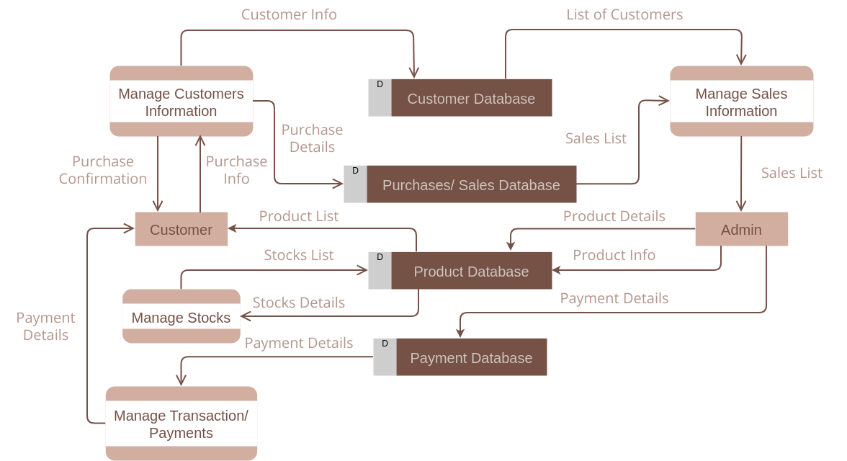

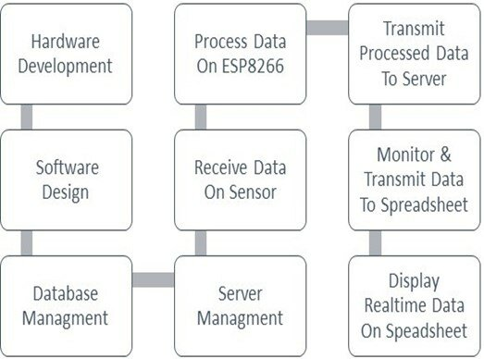

# CODE SKELETON

# import pandas as pd

# import numpy as np

# import matplotlib.pyplot as plt

# # Define inventory data directly as a DataFrame

# data = pd.DataFrame({

# "Product ID": ["P001", "P002", "P003", "P004", "P005",

# "P006", "P007", "P008", "P009", "P010"],

# "Product Name": ["Wireless Mouse", "USB Keyboard", "HDMI Cable",

# "External Hard Drive", "Laptop Stand", "Wireless Earbuds",

# "Monitor 24\"", "Gaming Mousepad", "Portable Charger",

# "Smartphone Holder"],

# "Stock Level": [50, 20, 70, 10, 60, 30, 15, 100, 40, 80],

# "Reorder Level": [30, 40, 50, 20, 30, 25, 10, 60, 35, 50],

# "Sales": [150, 100, 200, 50, 120, 80, 25, 300, 90, 250],

# "Lead Time (Days)": [5, 7, 3, 10, 4, 6, 12, 2, 8, 3],

# "Unit Cost": [10.5, 15.0, 8.0, 75.0, 22.5, 50.0, 120.0, 5.5, 18.0, 12.5],

# })

# # Clean and preprocess data

# data['Stock Level'] = data['Stock Level'].fillna(0)

# data['Reorder Level'] = data['Reorder Level'].fillna(data['Reorder Level'].mean())

# data['Sales'] = data['Sales'].fillna(0)

# # Key metrics

# data['Stock Turnover Ratio'] = data['Sales'] / (data['Stock Level'] + 1)  # Avoid division by zero

# data['Days of Inventory Outstanding'] = 365 / (data['Stock Turnover Ratio'] + 1)

# # Identify understocked and overstocked items

# data['Status'] = np.where(data['Stock Level'] < data['Reorder Level'], 'Understocked',

# np.where(data['Stock Level'] > data['Reorder Level'] * 2, 'Overstocked', 'Optimal'))

# understocked_items = data[data['Status'] == 'Understocked']

# overstocked_items = data[data['Status'] == 'Overstocked']

# print("Summary Insights:")

# print(f"Total Products: {len(data)}")

# print(f"Understocked Products: {len(understocked_items)}")

# print(f"Overstocked Products: {len(overstocked_items)}")

# # Visualization

# plt.figure(figsize=(10, 6))

# # Bar chart for stock status

# status_counts = data['Status'].value_counts()

# status_counts.plot(kind='bar', color=['red', 'blue', 'green'])

# plt.title("Inventory Stock Status")

# plt.ylabel("Number of Products")

# plt.xlabel("Stock Status")

# plt.xticks(rotation=0)

# plt.show()

# # Plot Stock Level vs. Reorder Level for all products

# plt.figure(figsize=(12, 8))

# plt.scatter(data['Stock Level'], data['Reorder Level'], c='orange', alpha=0.7)

# plt.title("Stock Level vs. Reorder Level")

# plt.xlabel("Stock Level")

# plt.ylabel("Reorder Level")

# plt.grid(True)

# plt.show()

# # Export insights to Excel

# output_file = "inventory_analysis_results.xlsx"

# with pd.ExcelWriter(output_file) as writer:

# data.to_excel(writer, sheet_name="Full Data", index=False)

# understocked_items.to_excel(writer, sheet_name="Understocked Items", index=False)

# overstocked_items.to_excel(writer, sheet_name="Overstocked Items", index=False)

# print(f"Analysis completed. Results saved to {output_file}")

**RESULT ANALYSIS**

The strategic imperative of inventory control management lies in its ability to transform organizational operations into a streamlined, responsive, and cost-effective system. At its core, inventory control ensures the right products are available at the right time and in the right quantities, balancing supply and demand while minimizing waste. This process is not just about tracking inventory; it encompasses a broader framework that includes forecasting, procurement, storage, distribution, and even disposal of surplus or obsolete items.

Organizations adopting advanced inventory control systems benefit from increased operational efficiency. Technologies like RFID, IoT sensors, and AI-powered predictive analytics allow real-time tracking and accurate demand forecasting. This reduces lead times and improves supplier relationships, ultimately leading to higher customer satisfaction and retention. Integration with Enterprise Resource Planning (ERP) systems enables centralized control over inventory-related activities, ensuring alignment with overall business strategies.

Furthermore, effective inventory management directly impacts financial performance. By reducing holding costs and avoiding overstocking or stockouts, businesses can free up working capital for other strategic investments. Practices like Economic Order Quantity (EOQ), safety stock calculations, and periodic inventory reviews help optimize stock levels and improve cash flow.

From a sustainability perspective, inventory control management also supports eco-friendly initiatives. Companies can minimize waste through better demand forecasting and efficient supply chain practices. Sustainable packaging and green warehousing further reduce environmental footprints, which is increasingly important in gaining customer trust and adhering to regulatory requirements.

In addition to operational and environmental benefits, inventory control is vital for risk management. Maintaining safety stock and diversifying suppliers can mitigate disruptions from unexpected demand spikes or supply chain issues. Advanced analytics tools can even predict potential risks, allowing proactive measures to address them.

Ultimately, effective inventory control management positions organizations to adapt swiftly to market dynamics, reduce operational costs, and enhance customer experience. It is a critical enabler of growth, competitiveness, and long-term success in today’s fast-paced business environment.

**OUTPUT SAMPLES**

